

|  |
| --- |
| *BS Cyber Security Department AU* |

|  |  |
| --- | --- |
| **Registration ID** | **233026** |
| **Submitted By** | **Muhammad Sohaib Rafiq** |
| **Submitted To** | **Iram Fatima Hashmi** |
| **Date of Submission** | **05/23/2025** |
| **Quiz NO.** | **2** |
| **Subject** | **NS LAB** |

***Quiz snort:***

***Starting the snort:***

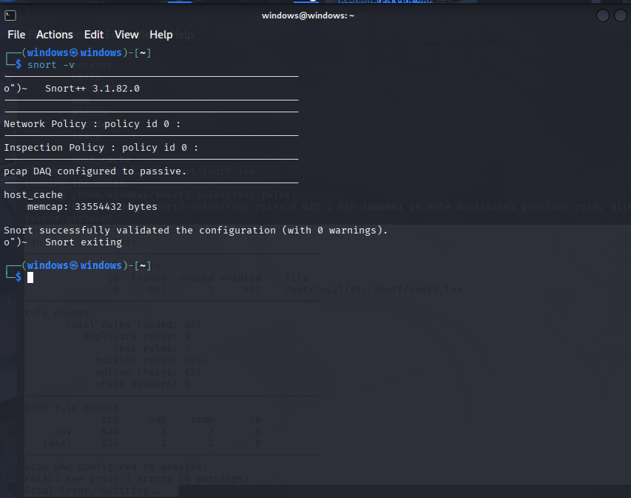

***Snort rules:***

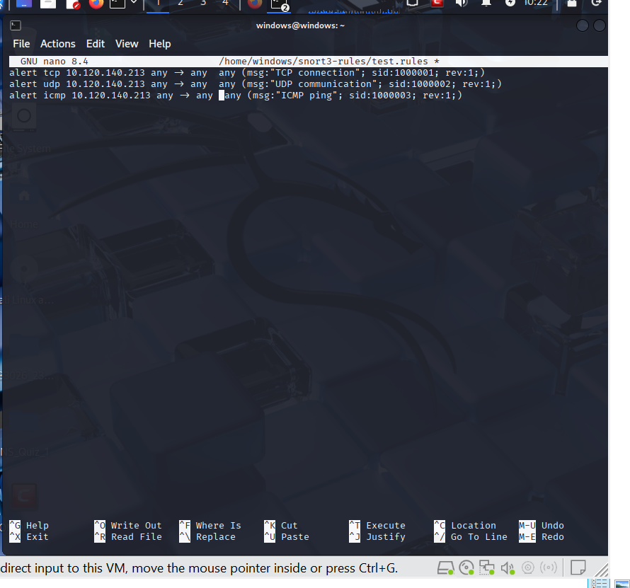

***Snort Results:***

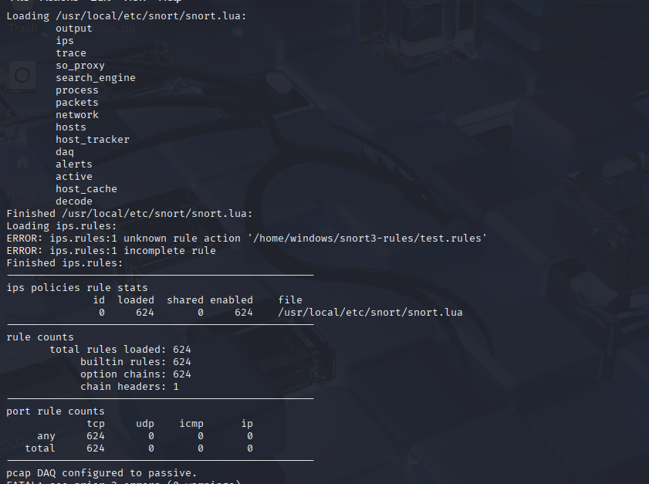

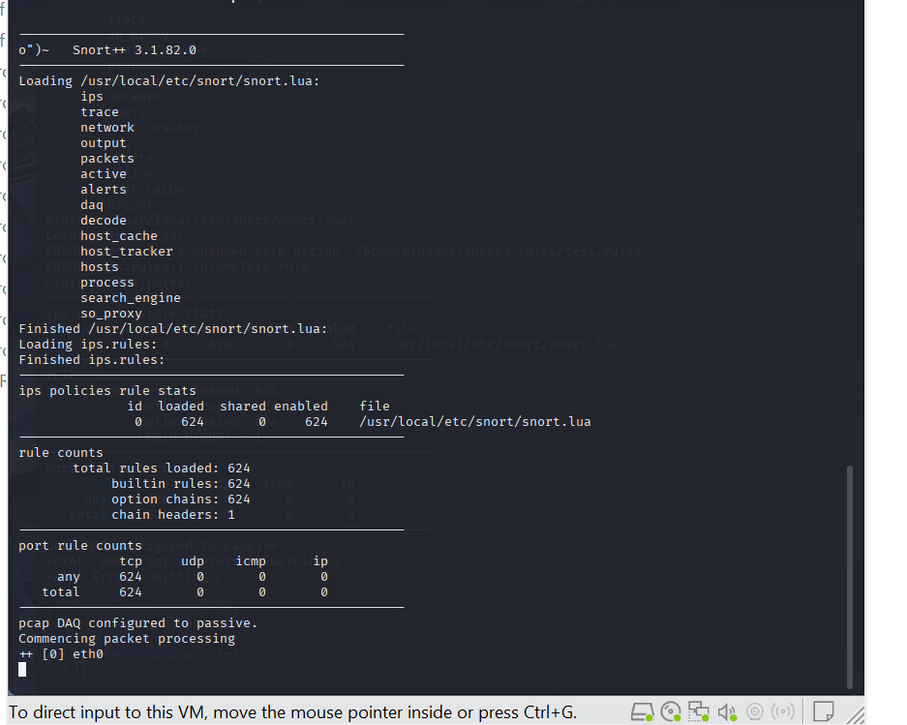

***Snort alerts when the I triggered the scapy scripts***

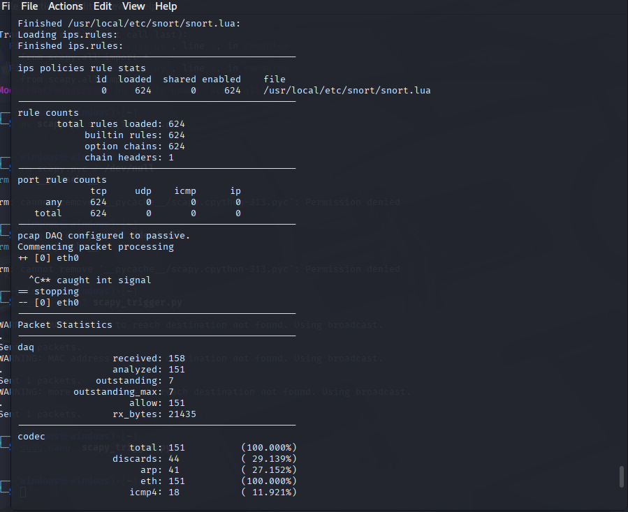

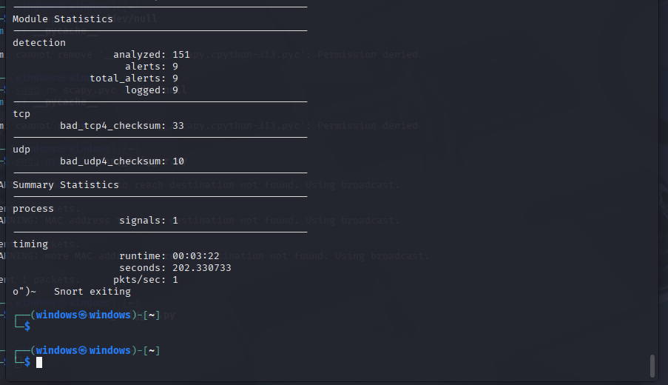

***Live packet Capturing :***

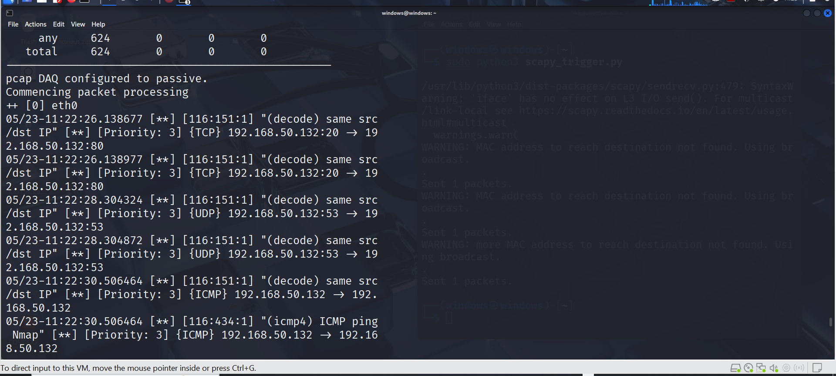

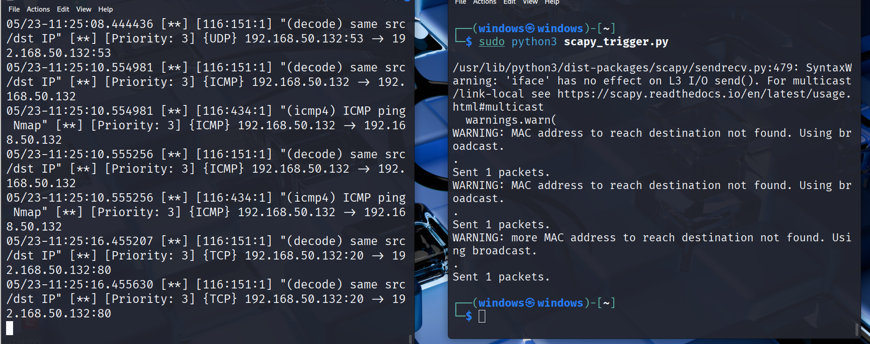

***And Scapy:***

***Rules:***

